Cloud Security – Capstone Project Assignment

Student Name: Samadhan Pawar
PRN: 2124UCSM1068
University: Sanjivani University
Department: CSE – Cyber Security Engineering

Topic: Deploy a Secure Three-Tier Application on AWS Using Terraform
This project is about building a secure AWS infrastructure using Terraform (Infrastructure as Code). You will create a VPC, deploy a Load Balancer in public subnets, host the application server in a private subnet, and keep the database isolated in a private database subnet.
I'll explain it in simple English, in a practical college-assignment format, including the architecture, working procedure, Terraform code structure, security configuration, and screenshots you should capture.

1. Aim
To design and deploy a secure, scalable three-tier application architecture on AWS using Terraform. The infrastructure will include a VPC, public and private subnets, Application Load Balancer, EC2 application server, RDS database, Internet Gateway, NAT Gateway, security groups, VPC Flow Logs and CloudTrail.

2. Introduction
A three-tier architecture divides an application into three separate layers:
- Presentation Tier: Receives user requests through the Application Load Balancer.
- Application Tier: Processes requests using an EC2 instance in a private subnet.
- Database Tier: Stores application data in an RDS database in a private subnet.
Terraform is an Infrastructure as Code (IaC) tool. It allows us to create and manage AWS infrastructure using configuration files instead of manually creating every resource.

3. Architecture Diagram
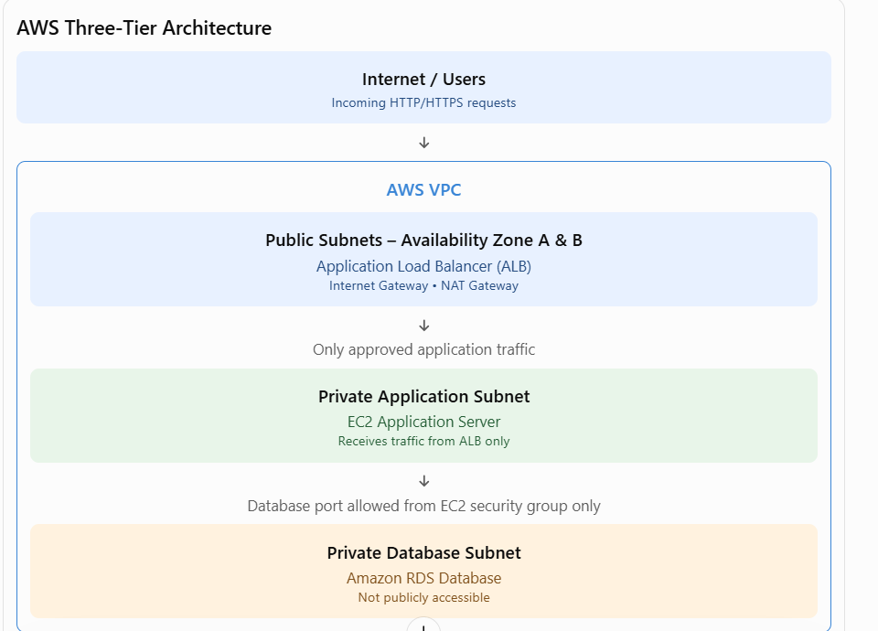

4. AWS Services Used
AWS service | Purpose
Amazon VPC | Creates an isolated virtual network
Public Subnet | Hosts internet-facing resources such as ALB
Private Subnet | Hosts application servers
Amazon EC2 | Runs the application
Application Load Balancer | Distributes incoming traffic
Amazon RDS | Stores application data
Internet Gateway | Allows public subnet internet connectivity
NAT Gateway | Allows private instances to access the internet outbound
Security Groups | Controls inbound and outbound traffic
VPC Flow Logs | Records network traffic information
CloudTrail | Records AWS account API activity
Terraform | Creates infrastructure through code

5. Working of the Three-Tier Architecture
Tier 1 – Presentation Layer
The Application Load Balancer is deployed in public subnets. It receives requests from users and forwards approved requests to the application server.
Tier 2 – Application Layer
An EC2 instance is deployed in a private application subnet. It processes user requests and communicates with the RDS database. It does not need a public IP address.
Tier 3 – Database Layer
Amazon RDS is deployed in private database subnets. It stores application information and accepts connections only from the application server's security group.

6. Network Configuration
Example network design:
Component | Example CIDR
VPC | 10.0.0.0/16
Public Subnet A | 10.0.1.0/24
Public Subnet B | 10.0.2.0/24
Private App Subnet A | 10.0.11.0/24
Private App Subnet B | 10.0.12.0/24
Private DB Subnet A | 10.0.21.0/24
Private DB Subnet B | 10.0.22.0/24
These are example IP ranges. They can be changed according to project requirements.

7. Security Group Configuration
Security groups act as virtual firewalls for AWS resources.
Security group | Inbound rule | Source
ALB-SG | HTTP 80 / HTTPS 443 | Internet, as required
APP-SG | Application port, e.g. 80 or 8080 | ALB-SG only
DB-SG | Database port, e.g. 3306 for MySQL | APP-SG only
Important security points:
- Do not allow public internet access directly to the EC2 application server.
- Do not allow public internet access to RDS.
- The database should accept connections only from the application security group.
- Use HTTPS for real application traffic.
- Avoid opening SSH to the whole internet. Prefer AWS Systems Manager Session Manager for administration.

8. Terraform Project Folder Structure
Create a project folder named secure-three-tier-aws.
secure-three-tier-aws/
│
├── main.tf
├── variables.tf
├── outputs.tf
├── provider.tf
├── terraform.tfvars
│
└── modules/
├── vpc/
├── alb/
├── ec2/
├── rds/
└── monitoring/
Purpose of files:
- provider.tf – Configures the AWS provider.
- main.tf – Defines AWS resources.
- variables.tf – Defines reusable variables.
- outputs.tf – Displays useful deployment information.
- terraform.tfvars – Stores project-specific variable values.
- modules/ – Organizes infrastructure into reusable components.

9. Terraform Implementation
First, install Terraform and configure AWS credentials using an approved method, such as an IAM role or AWS CLI profile. Do not write access keys directly into Terraform files.

A. AWS Provider Configuration
Create provider.tf:
terraform {
required_providers {
aws = {
source = "hashicorp/aws"
version = "~> 6.0"
}
}
}

provider "aws" {
region = "ap-south-1"
}
This example uses the Mumbai AWS Region.

B. Create VPC and Subnets
Create main.tf:
resource "aws_vpc" "main" {
cidr_block = "10.0.0.0/16"
enable_dns_support = true
enable_dns_hostnames = true

tags = {
Name = "Secure-Three-Tier-VPC"
}
}

resource "aws_subnet" "public_a" {
vpc_id = aws_vpc.main.id
cidr_block = "10.0.1.0/24"
availability_zone = "ap-south-1a"
map_public_ip_on_launch = true

tags = {
Name = "Public-Subnet-A"
}
}

resource "aws_subnet" "public_b" {
vpc_id = aws_vpc.main.id
cidr_block = "10.0.2.0/24"
availability_zone = "ap-south-1b"
map_public_ip_on_launch = true

tags = {
Name = "Public-Subnet-B"
}
}

resource "aws_subnet" "app_a" {
vpc_id = aws_vpc.main.id
cidr_block = "10.0.11.0/24"
availability_zone = "ap-south-1a"

tags = {
Name = "Private-App-Subnet-A"
}
}

resource "aws_subnet" "db_a" {
vpc_id = aws_vpc.main.id
cidr_block = "10.0.21.0/24"
availability_zone = "ap-south-1a"

tags = {
Name = "Private-DB-Subnet-A"
}
}
For a production-style RDS deployment, create a second private database subnet in another Availability Zone and use both in the DB subnet group. A second application subnet is also recommended for high availability.

C. Internet Gateway
resource "aws_internet_gateway" "igw" {
vpc_id = aws_vpc.main.id

tags = {
Name = "Three-Tier-IGW"
}
}
The Internet Gateway provides internet connectivity to resources in public subnets when their route tables and security rules permit it.

D. Security Groups
Example ALB security group:
resource "aws_security_group" "alb_sg" {
name = "ALB-SG"
vpc_id = aws_vpc.main.id

ingress {
from_port = 80
to_port = 80
protocol = "tcp"
cidr_blocks = ["0.0.0.0/0"]
}

egress {
from_port = 0
to_port = 0
protocol = "-1"
cidr_blocks = ["0.0.0.0/0"]
}
}
Example application security group:
resource "aws_security_group" "app_sg" {
name = "APP-SG"
vpc_id = aws_vpc.main.id

ingress {
from_port = 80
to_port = 80
protocol = "tcp"
security_groups = [aws_security_group.alb_sg.id]
}

egress {
from_port = 0
to_port = 0
protocol = "-1"
cidr_blocks = ["0.0.0.0/0"]
}
}
Example database security group for MySQL:
resource "aws_security_group" "db_sg" {
name = "DB-SG"
vpc_id = aws_vpc.main.id

ingress {
from_port = 3306
to_port = 3306
protocol = "tcp"
security_groups = [aws_security_group.app_sg.id]
}
}
The database security group has no public inbound rule. Only instances using the application security group can connect through the permitted database port.
These are core resource examples, not the complete deployment. The ALB, EC2, RDS, NAT, route tables and monitoring resources must also be defined and connected before applying the project.

10. NAT Gateway and Route Tables
The Internet Gateway is used by public subnets. A NAT Gateway allows resources in private subnets to initiate outbound internet connections without accepting unsolicited inbound internet connections.
Routing design:
Subnet | Route
Public subnets | Local VPC traffic + default route to Internet Gateway
Private application subnets | Local VPC traffic + default route to NAT Gateway
Private database subnets | Local VPC traffic; no direct internet route required
For a highly available deployment, use a NAT Gateway in each Availability Zone and route each private application subnet through its same-AZ NAT Gateway. NAT Gateways have hourly and data-processing costs.

11. Application Load Balancer, EC2 and RDS
Application Load Balancer:
- Create an internet-facing ALB.
- Select both public subnets.
- Attach the ALB security group.
- Create a target group for the application server.
- Configure a health check path such as /.
EC2 Application Server:
- Launch EC2 in the private application subnet.
- Attach the application security group.
- Install and run the application.
- Register the EC2 instance with the ALB target group.
- Use Systems Manager or another secure administration method.
RDS Database:
- Create an RDS DB subnet group using private database subnets in at least two Availability Zones.
- Set publicly_accessible = false.
- Attach the database security group.
- Store database credentials securely in AWS Secrets Manager.
- Enable encryption and backups.

12. Security Monitoring
A. VPC Flow Logs
VPC Flow Logs record information about IP traffic going to and from network interfaces in the VPC. They help identify accepted and rejected traffic.
B. AWS CloudTrail
CloudTrail records AWS API activity, including actions performed through the AWS Console, CLI and SDKs. It helps administrators investigate changes and monitor account activity.
Both services help improve visibility and security monitoring.

13. Terraform Deployment Commands
Run these commands from the project directory:
Step 1 – Initialize Terraform
terraform init
Downloads the required provider plugins and initializes the working directory.
Step 2 – Validate Configuration
terraform validate
Checks whether the Terraform configuration is valid.
Step 3 – Format Code
terraform fmt
Formats Terraform files consistently.
Step 4 – Preview Infrastructure Changes
terraform plan
Displays the resources Terraform intends to create, modify or delete.
Step 5 – Deploy Infrastructure
terraform apply
Review the plan and type yes when you are ready to deploy.
Step 6 – Remove Resources After Testing
terraform destroy
Review carefully before confirming. This deletes Terraform-managed infrastructure and may cause data loss.

14. Testing and Verification
After deploying the infrastructure, perform the following tests:
Test | Expected result
Open ALB DNS name in browser | Application should load
Access EC2 directly from internet | Should not be publicly accessible
Connect to RDS from EC2 | Should work with correct credentials
Connect to RDS from public internet | Should fail
Check VPC Flow Logs | Network traffic records should be available
Check CloudTrail | AWS API activity should be recorded

15. Screenshots to Capture for Submission
Take actual screenshots from your AWS Console and terminal after deployment.
Screenshot checklist
0 of 13 completed
0%
Terraform init, validate and plan output
VPC showing the configured CIDR
Public and private subnet configuration
Internet Gateway attached to the VPC
NAT Gateway configuration
Route tables and their subnet associations
ALB showing active status
EC2 instance showing private IP address
RDS database showing Publicly accessible: No
Security groups showing ALB-to-EC2 and EC2-to-RDS rules
VPC Flow Logs configuration
CloudTrail event history
Application successfully opening through ALB DNS

16. Advantages of the Project
- Better Security: The database and application server are isolated from direct public access.
- Scalability: The ALB can distribute requests across multiple application servers.
- High Availability: Resources can be deployed across multiple Availability Zones.
- Automation: Terraform creates infrastructure using reusable code.
- Monitoring: VPC Flow Logs and CloudTrail provide security visibility.
- Cost Management: Infrastructure can be reviewed and removed after practical testing.

17. Result
The project aims to successfully deploy a secure three-tier application architecture on AWS using Terraform. The architecture includes a VPC, public and private subnets, Application Load Balancer, EC2 application server and private RDS database. Network traffic is controlled using security groups and route tables. VPC Flow Logs and CloudTrail are configured for security monitoring.

18. Conclusion
This capstone project demonstrates how to build a secure and scalable cloud infrastructure using AWS and Terraform. The three-tier architecture separates the presentation, application and database layers. Public access is restricted to the Load Balancer, while the application server and database remain in private subnets. Security groups control communication between the tiers, and monitoring services help track network traffic and AWS activities.
Terraform makes infrastructure deployment easier, repeatable and manageable through code.

19. References
- AWS VPC Documentation – https://docs.aws.amazon.com/vpc/
- Terraform AWS Provider – https://registry.terraform.io/providers/hashicorp/aws/latest/docs
- AWS Application Load Balancer – https://docs.aws.amazon.com/elasticloadbalancing/
- Amazon EC2 – https://docs.aws.amazon.com/ec2/
- Amazon RDS – https://docs.aws.amazon.com/AmazonRDS/latest/UserGuide/
- AWS CloudTrail – https://docs.aws.amazon.com/awscloudtrail/
- VPC Flow Logs – https://docs.aws.amazon.com/vpc/latest/userguide/flow-logs.html

Important points before performing the practical
- The Terraform snippets above are examples of individual resources, not a complete ready-to-run project. You still need to define and connect all resources, including the ALB, target group, EC2, RDS, NAT Gateway, route tables and logging.
- Use at least two Availability Zones for the ALB and RDS subnet group.
- Keep the database private and do not put database passwords directly in Terraform code.
- Terraform state files can contain sensitive information. Protect the state file and use a secure remote backend for team or production work.
- Check AWS pricing before deployment. NAT Gateways, ALB, EC2, RDS and logging can generate charges even during a student practical.

